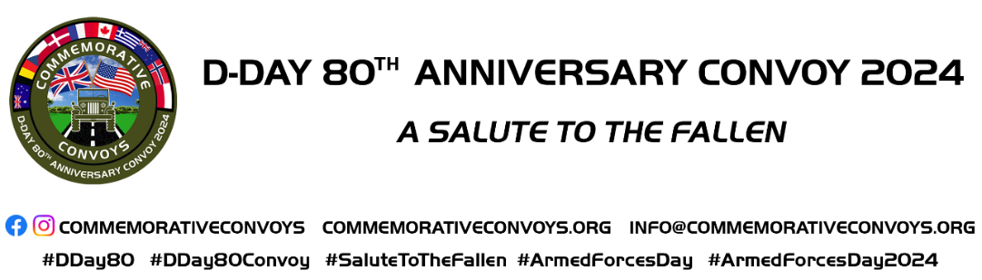

OFFICIAL D-DAY 80th ANNIVERSARY COMMEMORATIVE WEEKEND
Hungerford, West Berkshire 29/30 June 2024

LIVING HISTORY APPLICATION FORM

Name (s):

Email Address:

Telephone Number:

GROUP NAME (if applicable):

Group contact (if different from above):

Names of group members attending – please use a separate sheet for additional names if required and return with this form (thanks)

Portrayal (s) If more than ONE, please use a separate sheet and return with this form (thanks)

Display (if applicable) Space Required and contents of the display.

If you require period camping on the show site, please advise the space required.

If you require modern off-site camping, please advise the space required.

Space is available free of charge and facilities include loos and showers.

Active Public Liability Insurance is required. Please advise policy number and company:

Please complete and return this form to claire.barnes@hungerford-tc.gov.uk by 5th May 2024.
If you have any questions, please email or telephone 077 483 10996. Please sign and date below.

Sign: Date:

